Logotip Parade učenja® 2015
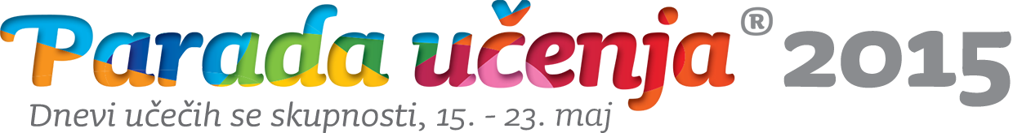
Learning Parade® 2015 Logo

Design: David Fartek

